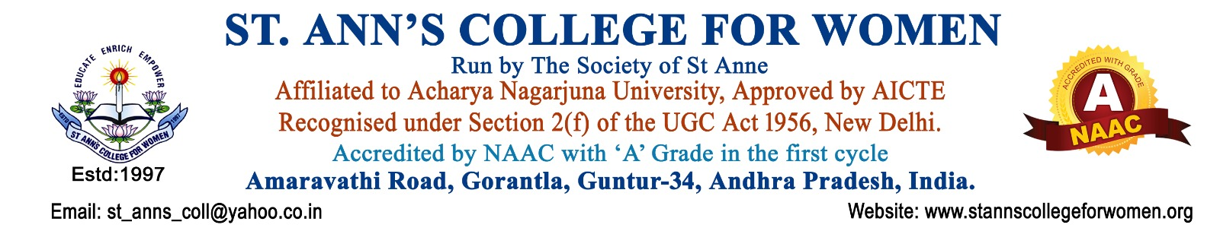

B.Sc Honours – Computer Science
Empowering Future Technology Leaders
The B.Sc Honours – Computer Science programme at St. Ann’s College for Women is a dynamic four-year undergraduate programme designed to develop strong foundations in computer science, programming, software development, data science, networking, artificial intelligence, and emerging technologies.
The programme blends academic excellence with intensive practical training to prepare students for successful careers in the IT industry, research, entrepreneurship, and higher education.
Note: St. Ann’s College for Women presently offers the B.Sc Honours -Computer Applications programme as a Three-Year Degree Programme in accordance with the Acharya Nagarjuna university and government guidelines.
Programme Highlights
- Industry-oriented curriculum with practical exposure
- Hands-on programming and software development laboratories
- Training in C, Java, Python, PHP, MERN Stack & Mobile App Development
- Special focus on Artificial Intelligence, Machine Learning & Data Science
- Web Development and Database Management training
- Real-time projects, seminars, workshops & internships
- Skill development for placements and higher education
- Career opportunities in software, analytics, networking & IT services
- Coding skill enhancement and project-based learning
- Exposure to latest technologies and industry trends
Core Subjects Offered
Programming & Software Development
- Problem Solving Using C
- Data Structures Using C
- OOPS Through JAVA
- Python Programming
- Software Engineering
Computer Science Fundamentals
- Computer Fundamentals and Office Automation
- Digital Logic Design
- Computer Organisation
- Operating Systems
- Computer Networks
Database & Web Technologies
- Database Management Systems
- Web Interface Design Technologies
- Web Application Development using PHP & MySQL
- MERN Stack
Emerging Technologies
- Data Science with R
- Python for Data Science
- Data Visualization Tools
- Machine Learning
- Mobile Application Development
Practical Learning
Every major course includes practical laboratory sessions to strengthen coding, analytical thinking, problem-solving, and application development skills. Students gain hands-on experience through mini projects, seminars, workshops, assignments, and internship opportunities.
Laboratory Facilities
- Well-equipped Computer Laboratories
- High-Speed Internet & Wi-Fi Facility
- Latest Software and Programming Tools
- Dedicated Labs for Programming, Data Science & Web Technologies
- Hands-on Practice Environment for Technical Skill Development
Value Added Features
- Internship & Industrial Training Support
- Coding & Technical Skill Development Programmes
- Soft Skills and Communication Training
- Placement Assistance & Career Counseling
- Guest Lectures by Industry Experts
- Workshops on Emerging Technologies
- Entrepreneurship & Startup Awareness
- Participation in Hackathons and Technical Competitions
- Digital Learning Resources & E-Content Support
Student Development Activities
- Seminars & Technical Presentations
- Coding Competitions & IT Fests
- Group Discussions & Personality Development Sessions
- Leadership and Team Building Activities
- Community Service Activities through NSS
Career Opportunities
Graduates can pursue careers as:
- Software Developer
- Web Developer
- Mobile App Developer
- Data Analyst
- Machine Learning Engineer
- Network Engineer
- System Analyst
- Software Tester
- Technical Support Engineer
- IT Consultant
Higher Education Opportunities
Students may pursue:
- MCA
- M.Sc Computer Science
- M.Sc Data Science
- M.Sc Artificial Intelligence
- M.Sc Cyber Security
- MBA (IT & Systems)
Placement & Career Support
The college provides continuous career guidance and placement support through:
- Resume Building Sessions
- Mock Interviews
- Aptitude & Technical Training
- Internship Opportunities
- Industry Interaction Programmes
- Career Guidance & Placement Assistance
Eligibility
Students who have completed Intermediate / 10+2 from a recognized board are eligible to apply.
Proposed Minor Subject
- Mathematics

Vision of the Programme
To develop competent, innovative, and socially responsible computer science professionals equipped with technical knowledge, ethical values, and leadership qualities.
Mission of the Programme
- To provide quality education in Computer Science and emerging technologies
- To promote practical learning, research, and innovation
- To prepare students for employment, entrepreneurship, and higher education
- To develop communication, leadership, and professional skills
Why Choose B.Sc Honours – Computer Science?
- Modern and industry-focused curriculum
- Strong practical and laboratory training
- Training in latest technologies and programming languages
- Holistic student development
- Real-time projects and internships
- Career guidance and placement support
- Excellent environment for higher education and research
Special Features of St. Ann’s College for Women
- NAAC Accredited Institution
- Safe & Student-Friendly Campus
- Holistic Development Approach
- Experienced & Dedicated Faculty
- Modern Computer Laboratories
- ICT-Enabled Smart Classrooms
- Practical & Skill-Based Learning
- Career Guidance & Placement Support
- Workshops, Seminars & Technical Events
- Personality & Communication Skill Training
- Women Empowerment & Leadership Development
- Sports, Cultural & Extracurricular Activities
- Scholarships & Student Support Services
- Focus on Discipline, Ethics & Values
- Excellent Environment for Higher Education & Career Growth
St. Ann’s College for Women is committed to empowering young women with knowledge, skills, confidence, and values for a successful future.

Contact Us
St. Ann’s College for Women
Gorantla, Guntur – 522034
Andhra Pradesh
📞 Landline: 0863-2236470
📱 Mobile: 73821 04655, 85006 56134
🌐 Website: www.stannscollegeforwomen.ac.in
✉ Email: st_anns_coll@yahoo.co.in

